**SECTION GD**

**FUEL RESERVOIR**

CONTENTS

|  |  |
| --- | --- |
|  | Chapter |
| General | 1 |
| Servicing | 2 |

CHAPTER 1

GENERAL

1. The fuel reservoir, which is mounted at the free end of the engine, serves three purposes. It:-
2. Allows any entrapped air in the fuel to be separated out before it is supplied to the fuel injection pumps.
3. Controls the pressure in the fuel system via a relief valve in the upper portion or head casting.
4. Contains sufficient fuel to allow the engine to be started before the engine driven feed pump commences delivery.
5. The reservoir consists of upper section or head casting (6)(Fig GD.l) and lower section or body casting (10) secured together by setscrews (13) and sealed by 'O' ring (7). The body casting is divided into two compartments by web (9).
6. Fuel from the filters is supplied via inlet port (11) to first stage compartment (24) then to the LOWER fuel pump gallery rails via connections (22). Any air in the fuel separates out and is passed through slot (8) in web (9) to second stage compartment (20) from where it is vented into relief port (14) via drilling (19) in relief valve piston (4) and drilling (18) in valve carrier (1).
7. Fuel is returned from the UPPER fuel pump gallery rails via connections (21) to second stage compartment (20), where the relief valve assembly, mounted in the head casting above the compartment, controls the system pressure, relieving excess fuel into relief port (14). The valve is non-adjustable.
8. Fuel from the injector return rails is returned via connection (17) directly into relief port (14).

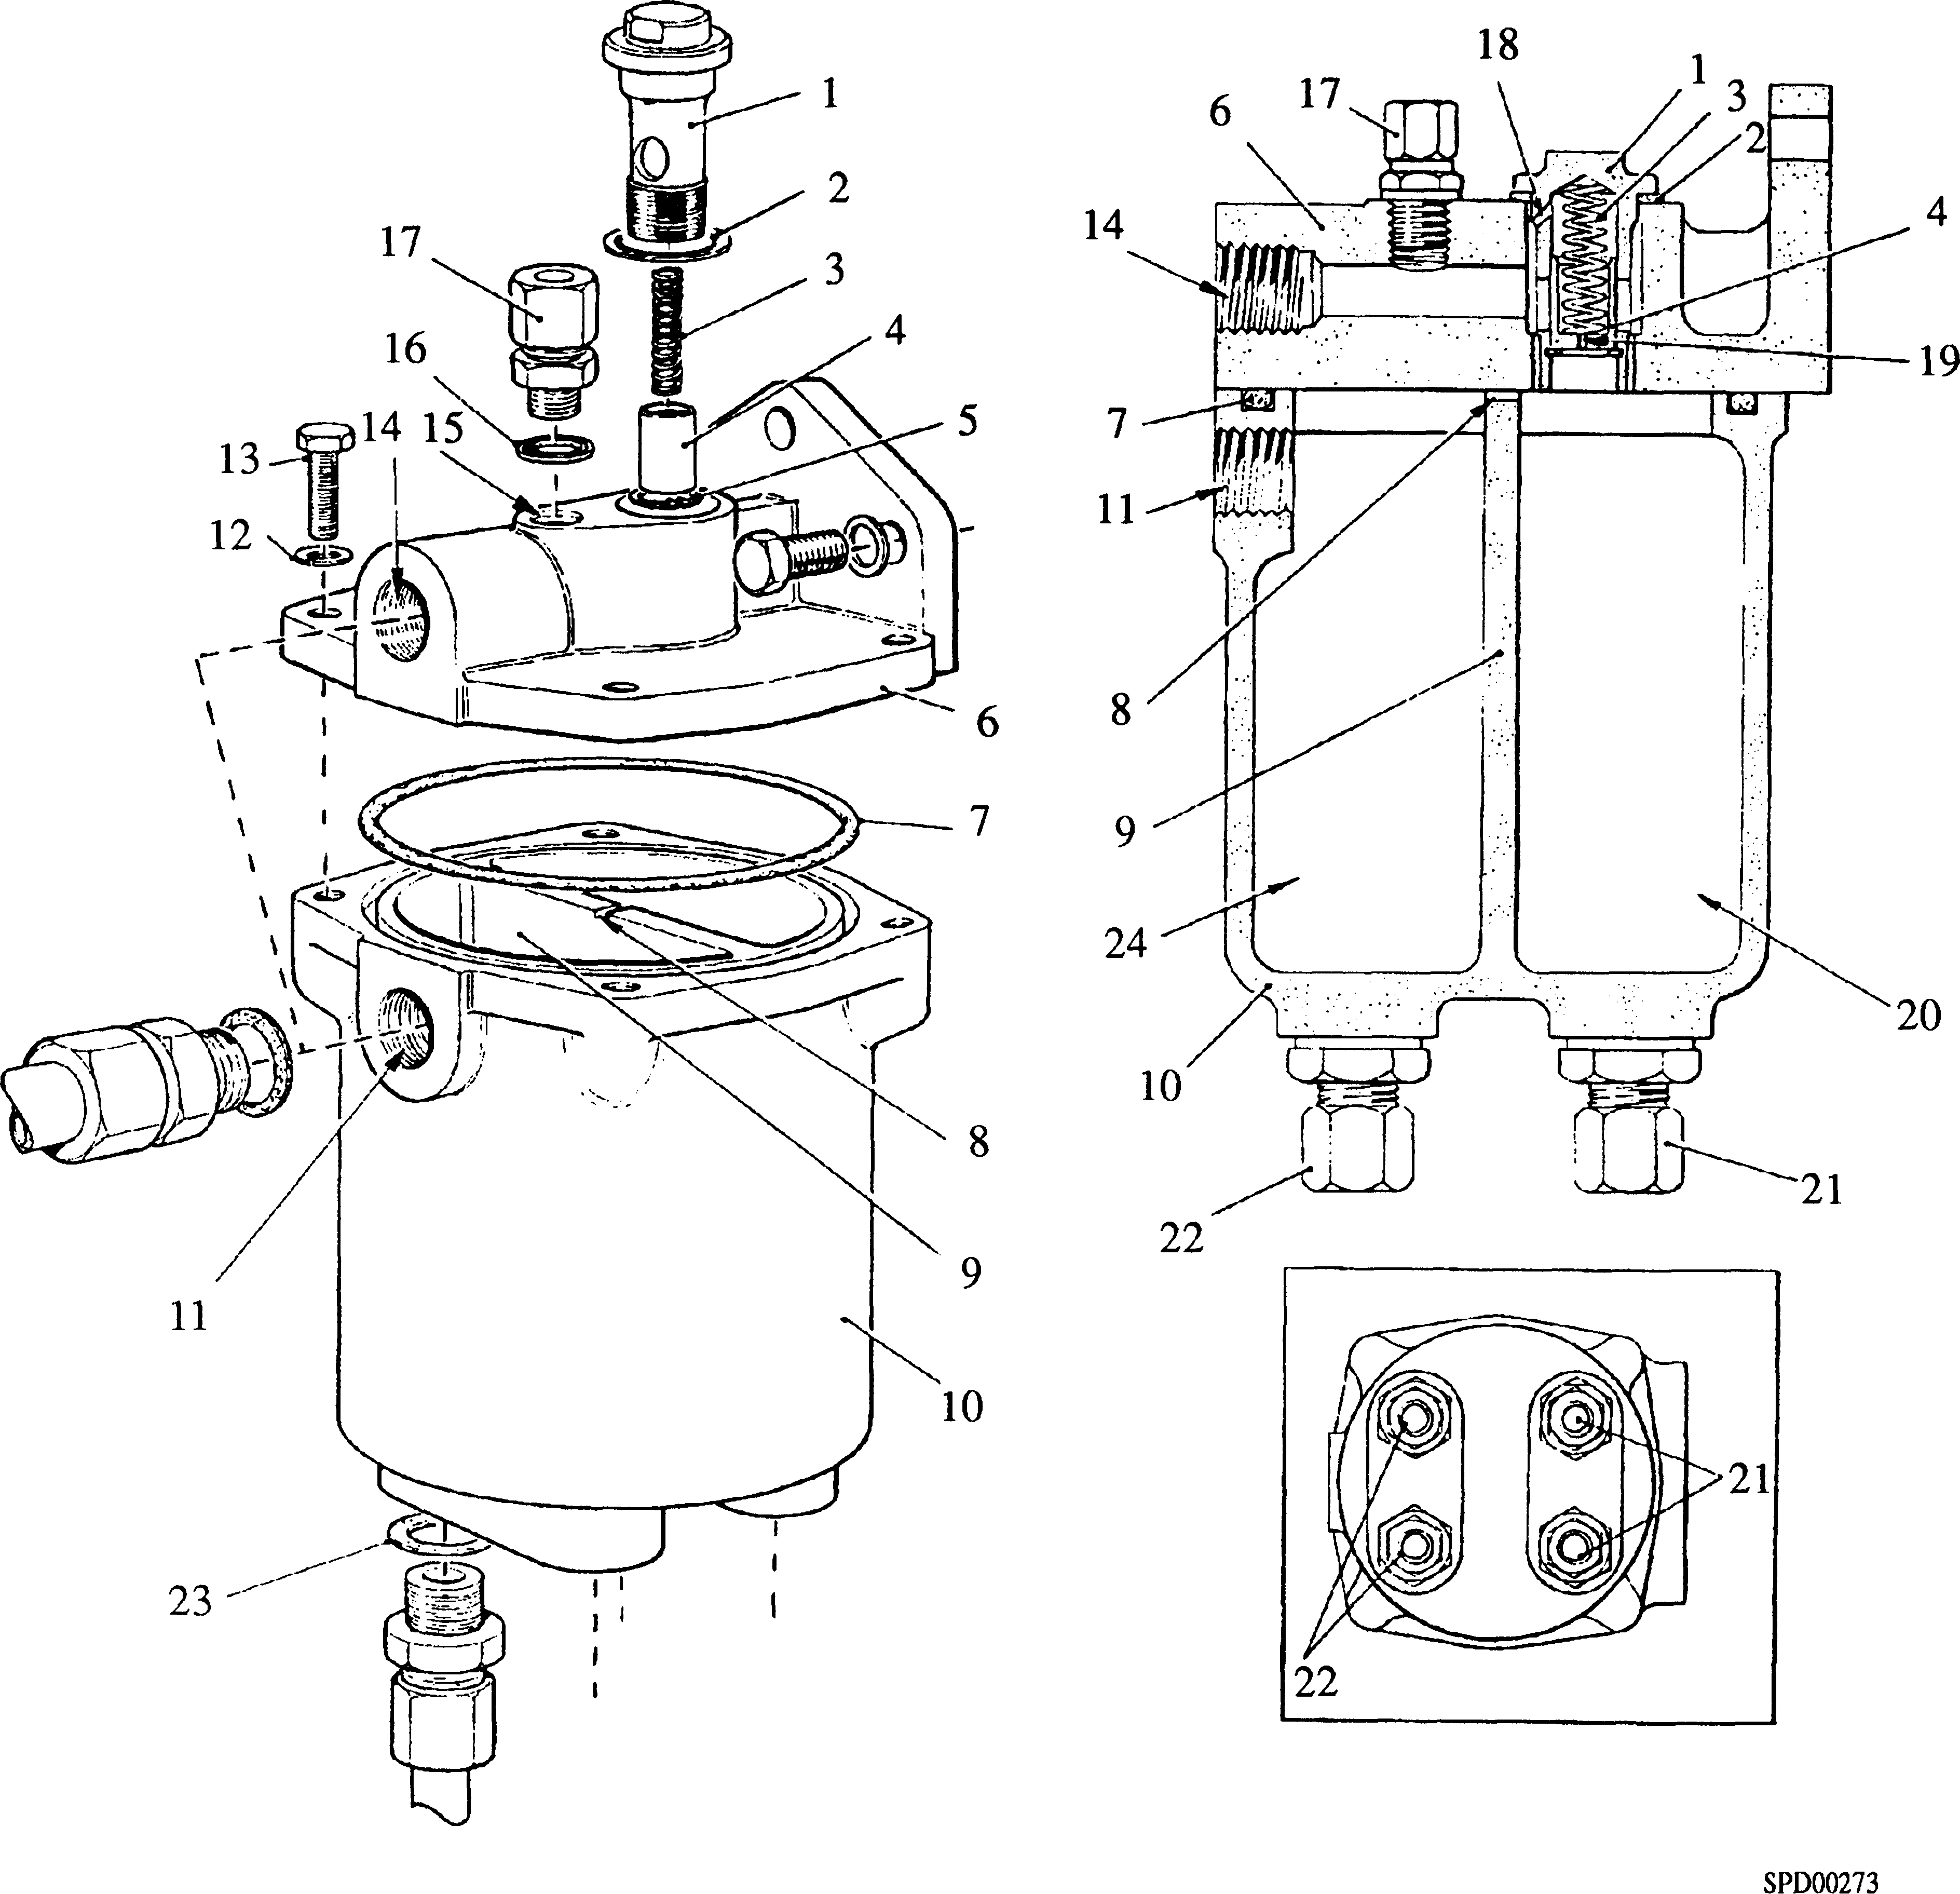

Key to Numbers.

|  |  |  |  |
| --- | --- | --- | --- |
| 1. | Relief valve carrier | 13. | Setscrew head to body |
| 2. | Dowty seal | 14. | Relief port |
| 3. | Relief valve spring | 15. | Inlet port (leak-off fuel) |
| 4. | Relief valve piston | 16. | Dowty seal |
| 5. | Relief valve piston retaining circlip | 17. | Connection from injector fuel return rails |
| 6. | Head casting (upper section) | 18. | Air drilling in carrier |
| 7. | 'O' ring, sealing head to body casting | 19. | Air drilling in relief piston |
| 8. | Air bleed slot between compartments | 20. | Second stage compartment |
| 9. | Dividing web | 21. | Connections to upper fuel galleries |
| 10. | Body casting (lower section) | 22. | Connections to lower fuel galleries |
| 11. | Fuel inlet port | 23. | Dowty seal |
| 12. | Spring washer | 24. | First stage compartment |

Fig GD.l Fuel reservoir

CHAPTER 2

TO SERVICE.

1. Disconnect fuel supply and relief piping to the reservoir.
2. Disconnect injector fuel return rail connection.
3. Disconnect piping to underside of the reservoir.
4. Release securing setscrews and remove the reservoir.

Dismantling

1. Release setscrews (13) and separate reservoir sections. Remove and discard 'O’ ring

(7).

1. Unscrew relief valve carrier (1) from head casting.
2. Remove circlip (5) and withdraw relief valve piston (4) and spring (3) from the carrier.
3. DO NOT remove pipe connections from the reservoir sections other than for renewal of dowty seals.

Inspection

1. Examine reservoir body for deposits of foreign matter, clean and thoroughly wash out with clean fuel oil.
2. Examine all mating faces for burrs and indentations which may affect sealing.
3. Check that relief valve slides smoothly in carrier bore and that the relief spring is not collapsed or distorted.
4. Check that air relief drillings through the relief valve piston and the valve carrier are unobstructed.
5. Examine all threaded portions for serviceability.

Assembly

NOTE All joints and 'O' rings must befitted dry.

1. Insert spring (3) and relief valve piston (4) into carrier (1), depress piston and fit circlip (5). Ensure that the circlip is correctly bedded in its groove.
2. Using a new dowty seal (2), fit relief valve assembly to the head casting.
3. Fit a new 'O' ring (7) to the groove in body casting (10), place head casting (6) in position and secure together with setscrews (13) and spring washers (12).
4. Refit inlet and outlet connections (22) and (21) using new dowty seals.

Fitting

1. Place reservoir in position and secure with setscrews and spring washers.
2. Connect piping between reservoir and fuel rails, reservoir and filter, reservoir and upper fuel return block and reservoir and injector fuel return rails.
3. Prime fuel system (Section DA).